> #Task -3

> i=iris

> boxplot(i)

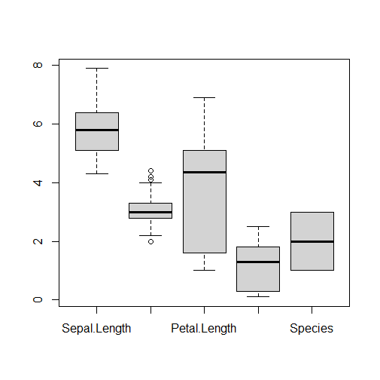

> str(i)

'data.frame': 150 obs. of 5 variables:

$ Sepal.Length: num 5.1 4.9 4.7 4.6 5 5.4 4.6 5 4.4 4.9 ...

$ Sepal.Width : num 3.5 3 3.2 3.1 3.6 3.9 3.4 3.4 2.9 3.1 ...

$ Petal.Length: num 1.4 1.4 1.3 1.5 1.4 1.7 1.4 1.5 1.4 1.5 ...

$ Petal.Width : num 0.2 0.2 0.2 0.2 0.2 0.4 0.3 0.2 0.2 0.1 ...

$ Species : Factor w/ 3 levels "setosa","versicolor",..: 1 1 1 1 1 1 1 1 1 1 ...

> hist(i[,1],col=3,main="SepalLength")

>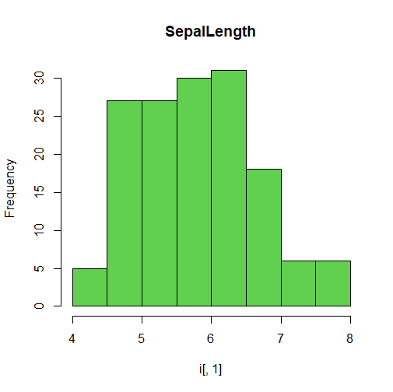

hist(i[,2],col=5,main="Sepal Width")

>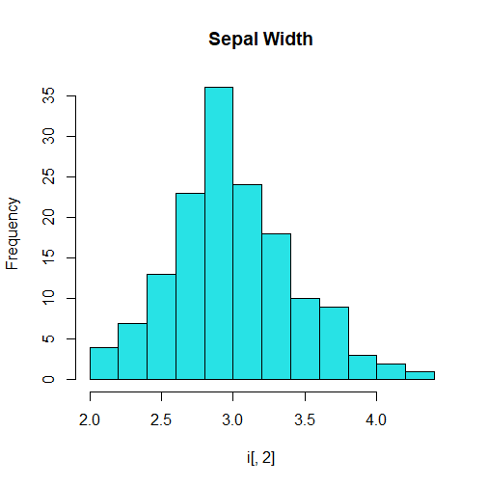

> hist(i[,3],col=7,main="Petal Length")

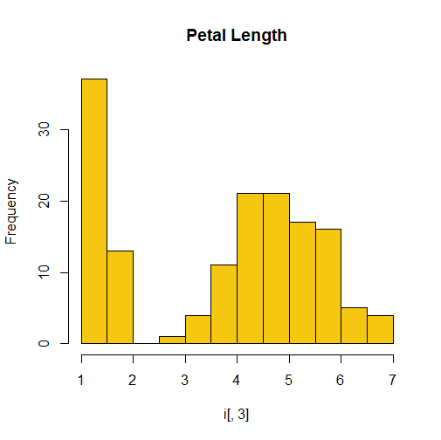

>hist(i[,4],col=3,main="PetalLength")

